***metin, giyim, adam, insan, ayakkabı içeren bir resim

Açıklama otomatik olarak oluşturuldu***

***TABLE of CONTENTS***

*1.* Project Proposal……………1

*2.* Project Management……..2

*2.1* Project Plan………..2-3

*2.2* Risk Plan…………….3

*SOFTWARE COMPANION*

**Project/Problem Description:** The aim of the project is to enable junior developers to benefit from the experience of senior developers and to integrate more easily into business life. Vision/What: Software Companion is a web-based application designed for the junior engineers to improve themselves.

**Issue/Why:** Users who want to learn the information/experiences that they cannot get from their environment can easily interact with people outside their own geography by using translation effectively thanks to the artificial intelligence integrated into the platform and reach the most appropriate information and guidance on the subject they want to get help on. This help is not just about code and algorithms, but it is more about experience (project management, human relations, finding the right resources, etc.). The same artificial intelligence also offers the user the chance to examine the solution methods and documents of people who have experienced similar problems and achieved solutions.

**Software Development Methodology/How?:** The platform suggests the best method and people with experience to solve the user's problem. Depending on the user's preference, it offers further steps to the user. Artificial intelligence technology and payment methods will be integrated and used in this platform. This application will enable less experienced software developers to integrate into the sector more easily and quickly.

***Project Management***

***Project Plan***

|  |  |  |
| --- | --- | --- |
| ***TASK*** | **TIME{DAYS}** | ***PREDECESSORS*** |
| A. Identifying the requirements of the project | 7 | - |
| B. Defining the scope | 4 | - |
| C. Task sharing | 1 | A |
| D. Financial planning | 5 | A,B |
| E. Risk planning | 6 | D |
| F. Starting the project | 2 | E |
| G. Quality control and improvements | 5 | F |

***Gantt Diagram***

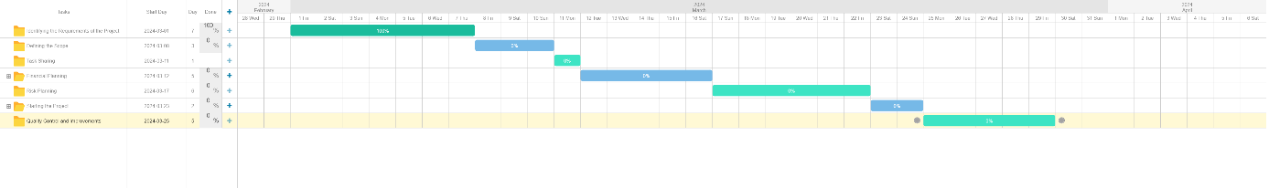

**Risk Plan**

|  |  |  |  |  |
| --- | --- | --- | --- | --- |
| **Risk Item** | **Impact** | **Action** | **Type** | **Risk Ratio** |
| **Problems with the payment** | **Financial losses** | **If there is a problem with the payment method, the commentator’s points will decrease.** | **Medium Risk** | **%3.5** |
| **Not being descriptive enough** | **Confusion of information** | **There will be a point scoring system, so the commentator’s points will decrease.** | **Low Risk** | **%2** |
| **Not coming to the meeting at required time** | **Loss of time** | **The scoring system we will use is also used here.** | **High Risk** | **%7.2** |